Final project report
Theme: Domestic Console Games
Zeng Shuman
1155160734
Web: http://zengshuman.pythonanywhere.com/

Catalog
1.Problem background
- 1.1 Introduction
- 1.2 Objectives
2.Requirements
- 2.1 Required Information
- 2.2 Information for searching
- 2.3 Information for purchasing
- 2.4 Information for peripheral products
3.Business Model
- 3.1 Membership
- 3.2 Promotion
4. Design
- 4.1 Structure
5. Test/Evaluation
- 5.1 Usability Test
- 5.2 Surface
- 5.3 A/B Test
- 5.4 Web analytics
- 5.5 Recommendations
6. Appendix

1.Problem background
1.1 Introduction
The website is built on Bootstrap 5 and Pythonanywhere, which focus on console games produced by Chinese teams or companies. Since the rise of domestic console games, more and more video game fans are paying attention to it. And the market share also extended rapidly both at home and abroad. The web site aims to help fans find interesting domestic video games and reliable information as a reference when they want to buy a game and get some peripheral products.
1.2 Objectives
As a console video game fan, there is no website or account that provides comprehensive information about console games especially those produced by Chinese companies because they are not the mainstream. There are numerous video game digital distribution channels that presently provide millions of PC video games, but it takes time for users to find something related domestic console games. Furthermore, if people want to get the most recent information about console games, they must spend a significant amount of time searching through a large number of websites, such as game reviews, peripheral products. For example, because its current information is fragmented, it is extremely inconvenient for me to obtain useful information in Chinese on a single integrated website.
To address the aforementioned issue, The web site aims to help fans find interesting domestic video games and reliable information as a reference when they want to buy a game and get some peripheral products.

2.Requirements
2.1 Required Information
In order to understand more accurately the needs of the site's target audience, I conducted interviews with five gamers separately who wanted to know about Chinese console games. The interview questions included, "If you wanted to play a game, what channels would you go to for information?" "Apart from the game itself, would you want to know about the game's peripheral products", etc. After that, I got some significant information and made a user journey map according to the result (Figure 1). Based on that, there were two problems needing to be solved. The first problem is to collect domestic games and integrate information together. The second one is to add a peripheral product page. Because most game fans have the habit of buying the products.
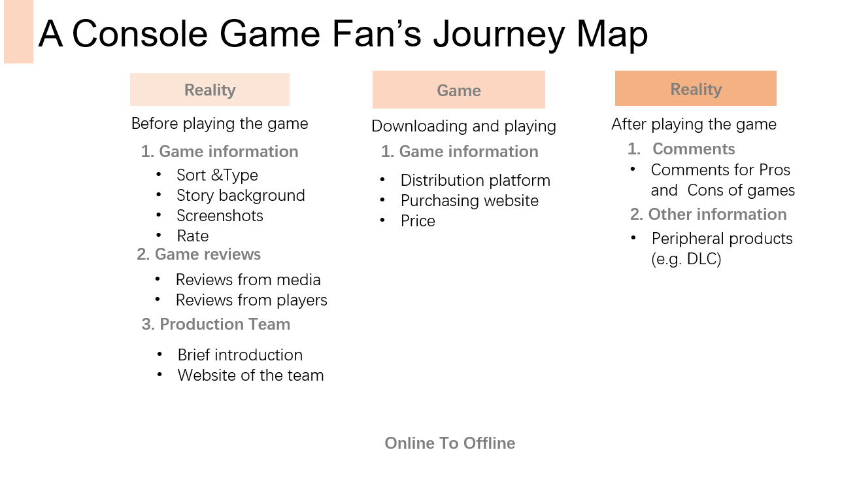
Figure 1. Journey map
2.2 Information for searching
- Games: About 30~50 popular console games produced by domestic companies and background for the production teams.
- Specific information about each game: type, characters, story background, screen shots and rates
- Reviews of games: Links of articles from some famous games’ media and articles from players.
- Visualization: making a rating chart/table showing the title of games, comparing the rate.
2.3 Information for purchasing
- Price, distribution platforms and links.
- Any discount (only for membership)
2.4 Information for peripheral products
- Peripheral products: types of products (electronic one or entity), purchasing links

3.Business Model
According to the previous interviews, most of the participants mentioned that they had the habit of buying some peripheral products about games. Moreover, it also was inconvenient for them to assess the information about latest peripherals. Therefore, the website tries to focus on this opportunity, providing users with peripheral products’ information.
This website connects the shops of peripherals (supply side) and video game lovers (demand side). At very beginning, the website will redirect users to the shops’ link for the payment, which cooperates with the shoppers who sell the peripheral products. And every time the users click the product button and complete the transaction, the website could generate income from this behavior.
3.1 Membership
In the home page, the audiences are informed that if they become members of the website, they could get discount of some games or peripherals. For common users, they could see the same content except the discount information but they are disable to leave comments.
More importantly, the record of how many resisted members of the website could persuade the peripheral shoppers or even the game distribution platform to cooperate with the website.
3.2 Promotion
At very beginning, the users can be attracted from some online video game fans group such as from QQ and WeChat, where the people share the common interests. Secondly, the website could invite some influencers in video game area to leave some reviewing passages and attract some fans to be the early adopters. Furthermore, when the users complete registration process, the website will have a record of users’ Email address, which enables the website to promote some discount information of games and products by sending email.

4. Design
4.1 Structure
Based on the above, the website id designed to fulfill these needs. As can be seen from the map of the website (Figure 2), the functional pages are divided into 5 parts, and the first four are related to video games. Followed are prototypes of the website.
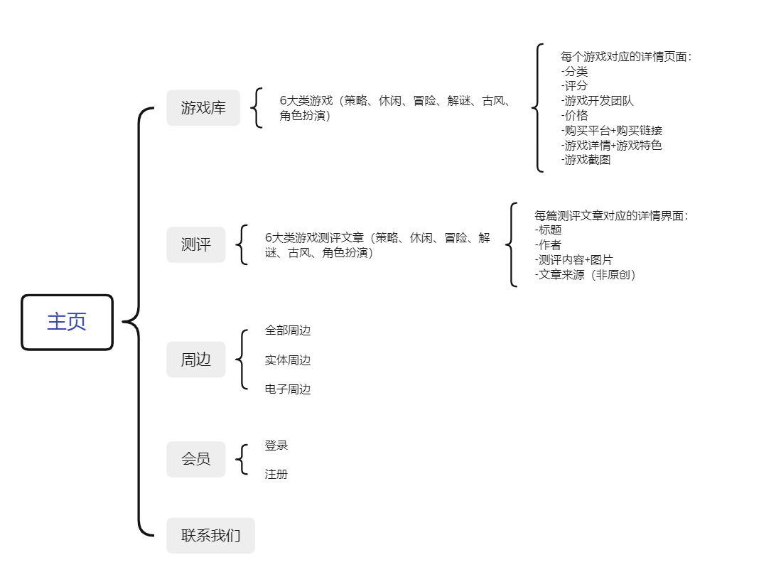
Figure 2. Site map
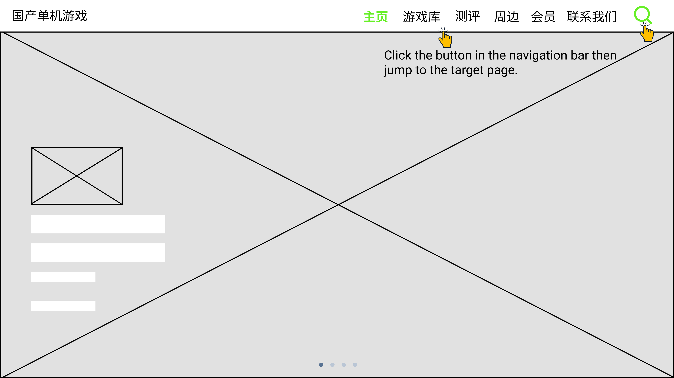
Figure 3. Prototype-Home page

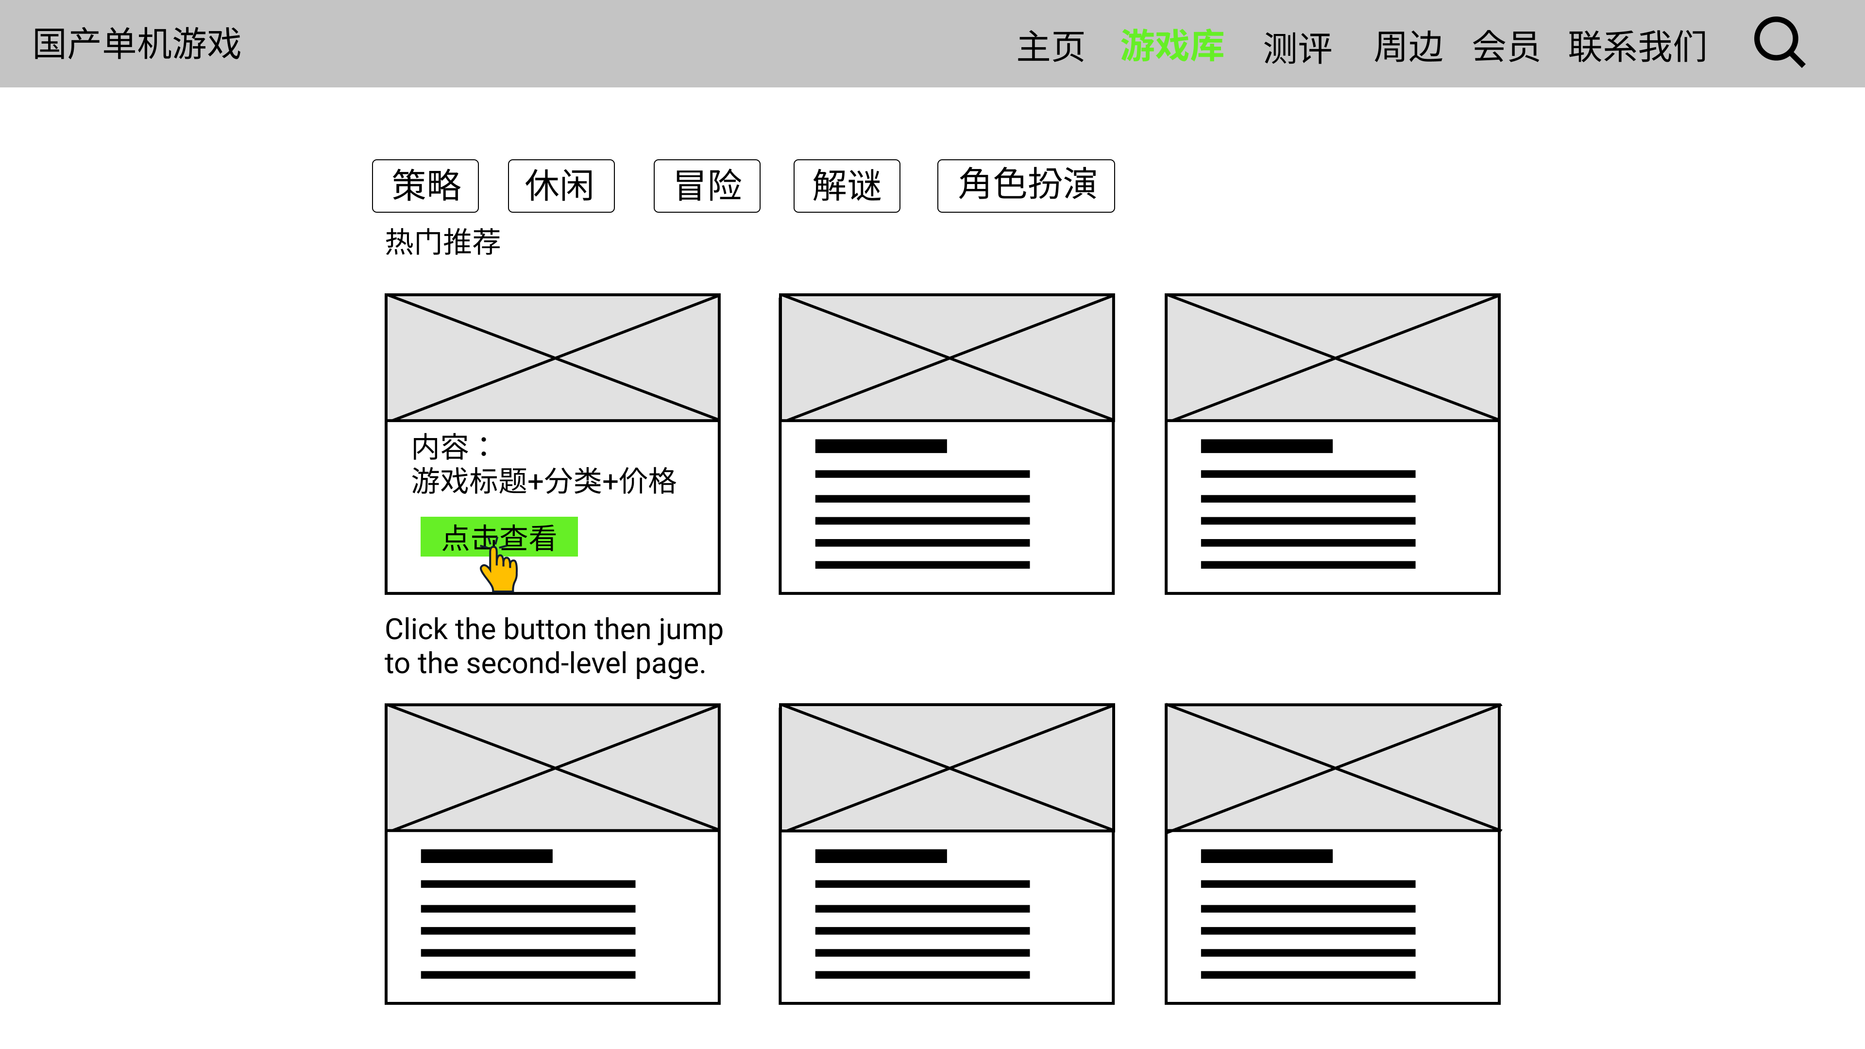
Figure 4. Prototype- “游戏库” page

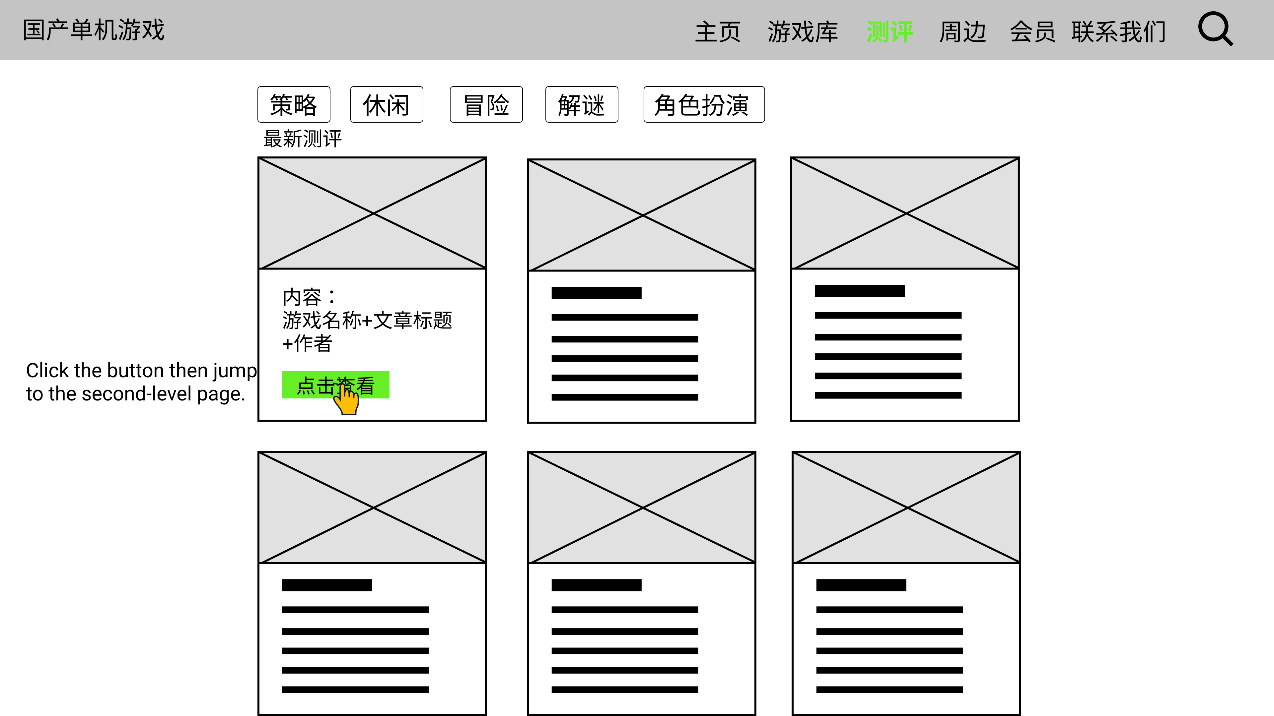
Figure 5. Prototype- “测评” page

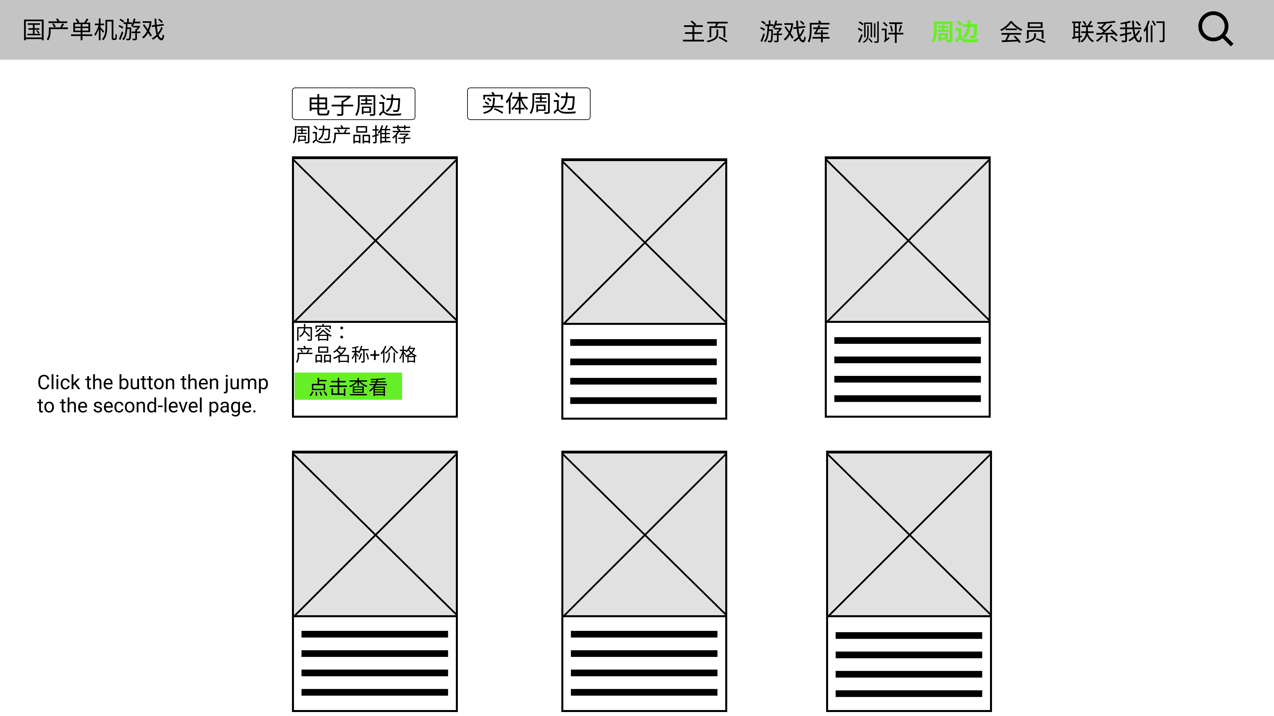
Figure 6. Prototype- “周边” page

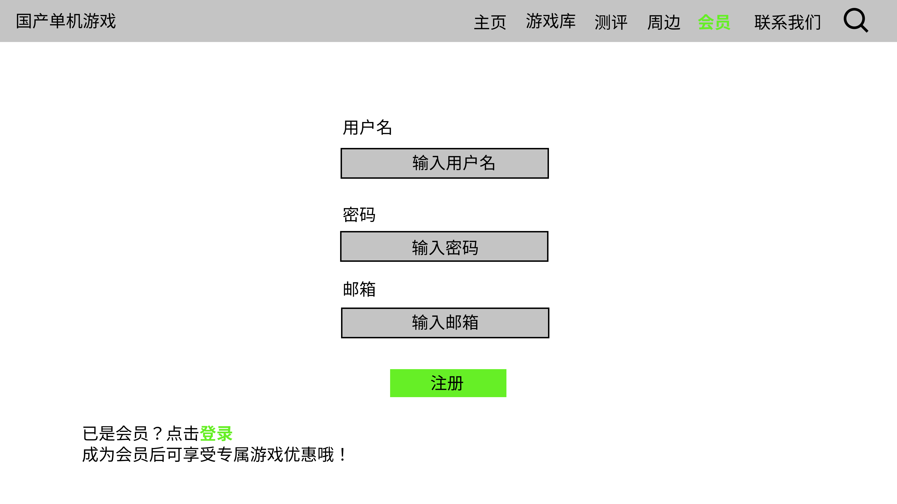
Figure 7. Prototype- Registering page
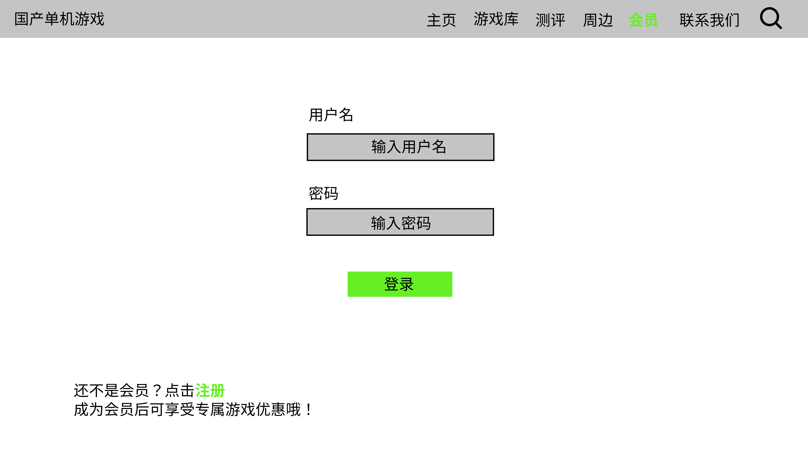
Figure 8. Prototype- Log-in page
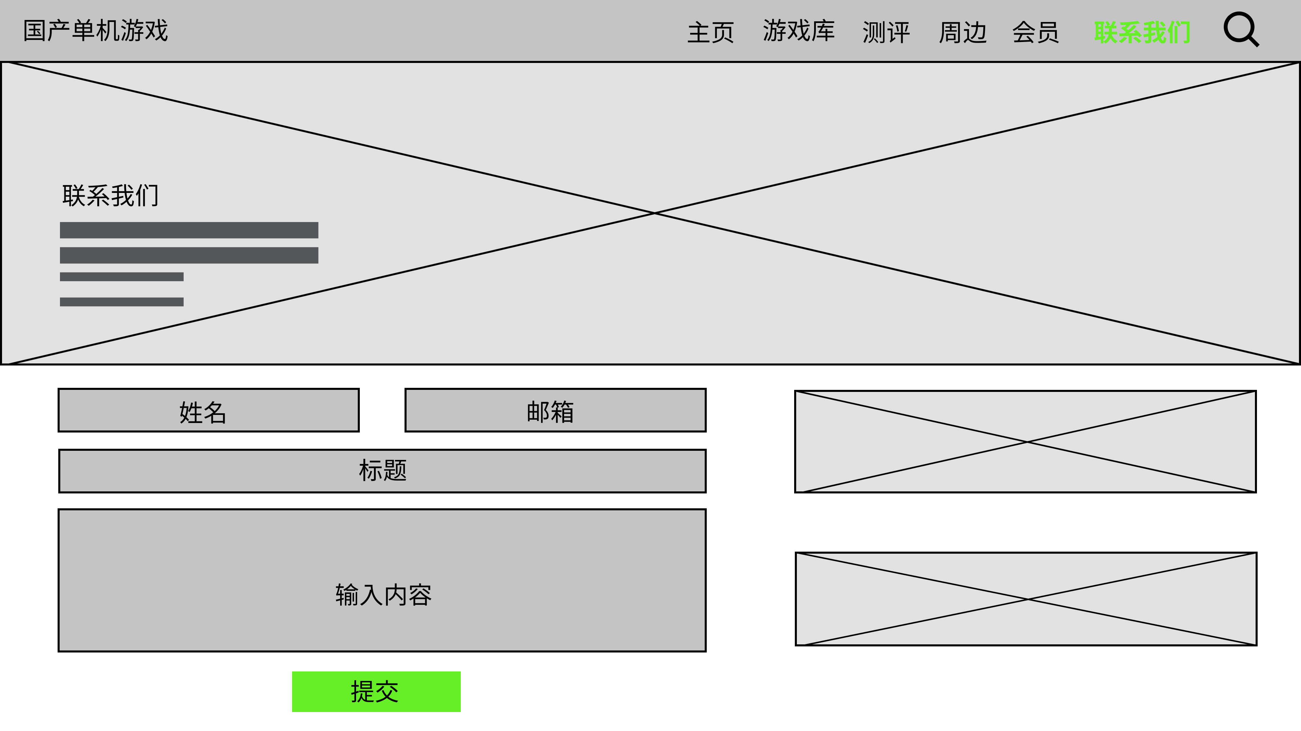
Figure 9. Prototype- Contact page
5. Test/Evaluation
5.1 Usability Test
After I completed the prototypes, I invited 5 video game lovers to do a usability test, all of whom are the target users of the website. And the questions and results are shown below (Figure 10).
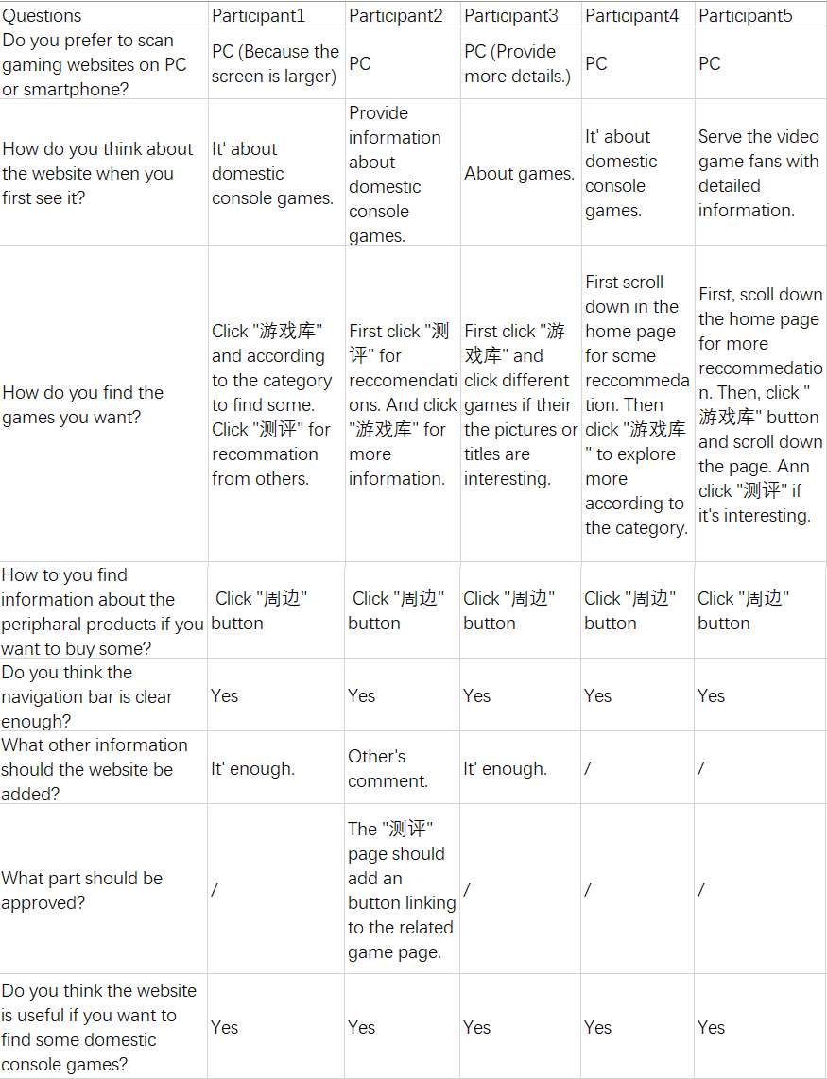
Figure 10. Usability test results

Based on the feedback from the test, I made some adjustment and combines the membership system with the prototype. One suggestion for improving the fluency provided by a respondent is that a function should be added for jumping to the page of game details from the page of reviewing passage (Figure 11).
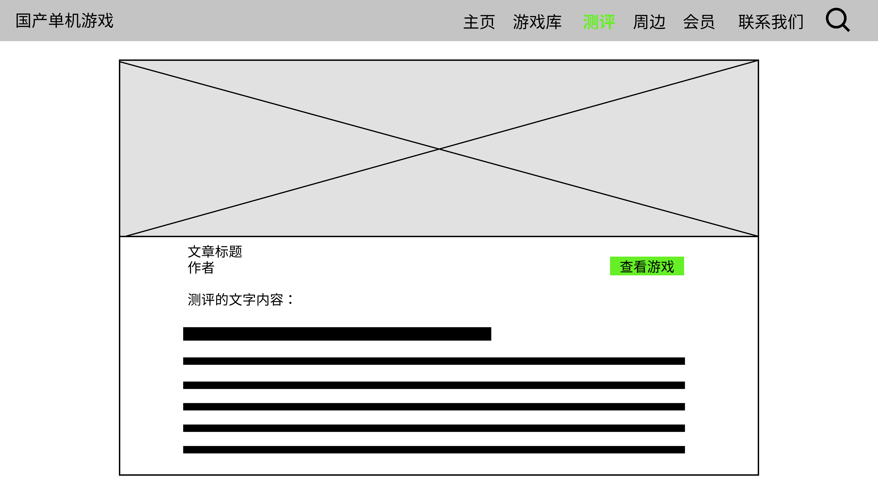
Figure 11. Page of reviewing passage

5.2 Surface
According to the results of usability test and some analysis tools, the websites were finally completed based on Bootstrap.
Web: http://zengshuman.pythonanywhere.com/

5.3 A/B Test
Google Optimize
- Goals：To gain more clicks of the "周边" button. As the peripheral page is important to generate income on this site, I wanted to apply an A/B test to see if the original version would be more successful than the variant (Figure 12)
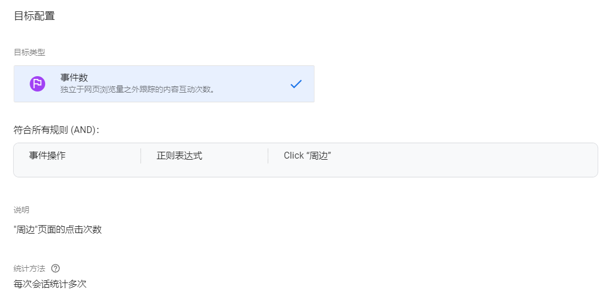
Figure 12. The goals of A/B test
- Variant version：Exchange the sequence of the “周边” button in the navigation bar.
Figure 13. The original version
Figure 14. The variant

- Assumption：Placing the "周边" button in front will increase user click-through rates.
- Experiment：The A/B test lasts from Nov.24 to Dec.12.
- Results:
According to the results (Figure 15), Google Optimize suggested that the variant version had the 91% probability to be the best one compared with original version. The calculated bounce rate original version was 33.33%, while the variant version had a higher calculated bounce rate of 64.29%, showing 18 of 28 had clicked the “周边” button. As for the goal s of gaining clicks of the “周边” button, the variant version did better.
Figure 15. A/B Test result (Data collected on 12/Dec.)

5.4 Web analytics
Google Analytics
Google Analytics is a great tool to help me know about my website’s performance. I applied Google Analytics to the website from November 17th to December 12nd, within nearly 26 days.
According to the record, 155 visitors had viewed the website, with 2,666 page views and 246 sessions. To my surprise, the average session duration was more than six minutes which was much higher than my expectancy (I guess this is because someone had opened the website and forgot closing it). Moreover, there were about 12% users visited the website more than once. More specifically, despite the landing page, “游戏库” page had more views than any others, followed by “周边” page and “测评” page (Figure 16).
Figure 16. Google Analytics results (Data collected on 12/Dec.)

In terms of devices, 76.78% (IOS & Android) of all users used mobile devices to view the website and just 23.22% of users adopted computers (Windows & MAC). The data indicated that most users preferred using mobile version and I have to focus more on developing the fluency of the operation for the mobile users. As for the country, most users were in mainland China which was align with the target users’ (Figure 17).
Figure 17. Google Analytics results (Data collected on 12/Dec.)

Google Tag Manager
The website has three event tracking on Google Tag Manager, which are related to the buttons on the navigation bar. As can be seen the picture of event flow (Figure 18), when users entered the website, nearly half of sessions went to the “游戏库” page first (22/43), followed by “周边” page (17/43) and “测评” page (3/43). However, the most users ended up the website when they entered the “周边” page. I assume the reason is that when users clicked the button on “周边” page, the website would redirect them to other pages out of the website and users might not come back. Based on that, it is a problem needs to be solved.
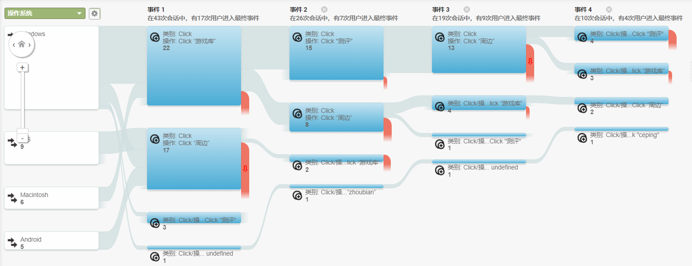
Figure 18. Google Analytics results-Event flow (Data collected on 12/Dec.)

5.5 Recommendation
Overall, there are several limitations of my whole project. Firstly, I had promoted the website in different channels, including WeChat, Tieba, and Weibo. However, I did not make a distinction for the user source channels which led to that I could not tell which channel had obtained most users. If I know which platform could attract more potential users, the future promotion of the website will be more effective. Secondly, the results may be inaccurate as I incorrectly set the target for the experiment in several previous A/B tests, resulting in an insufficient number of sessions for the latest experiment. Thirdly, I did not set the event tracking for the login and register button on Google Tag Manager, so I was not clear about the user’s willingness whether to be a member or not. For the future development, I need to consider whether the discount information is attractive enough for users to register in the website. For the business plan in the future, the characteristics of single player games is that they are bought out, which means that you can't make any more profit from the player other than buying the game and game peripherals are currently the only source of additional income. Therefore, I need to look deeper into the market for peripheral products and seek for more potential opportunities.

6. Appendix
- Bootstrap templates:
https://bootstrapmade.com/real-estate-agency-bootstrap-template/
- Data resources:
https://store.steampowered.com/
https://www.wegame.com.cn/
https://bbs.3dmgame.com/forum.php

